**Product Manager (Part II)**

Continue from the previous assignment. On the main page, below the product form, list out all of your products in your database. Then, create a route so that you can see the specifics for a particular product.

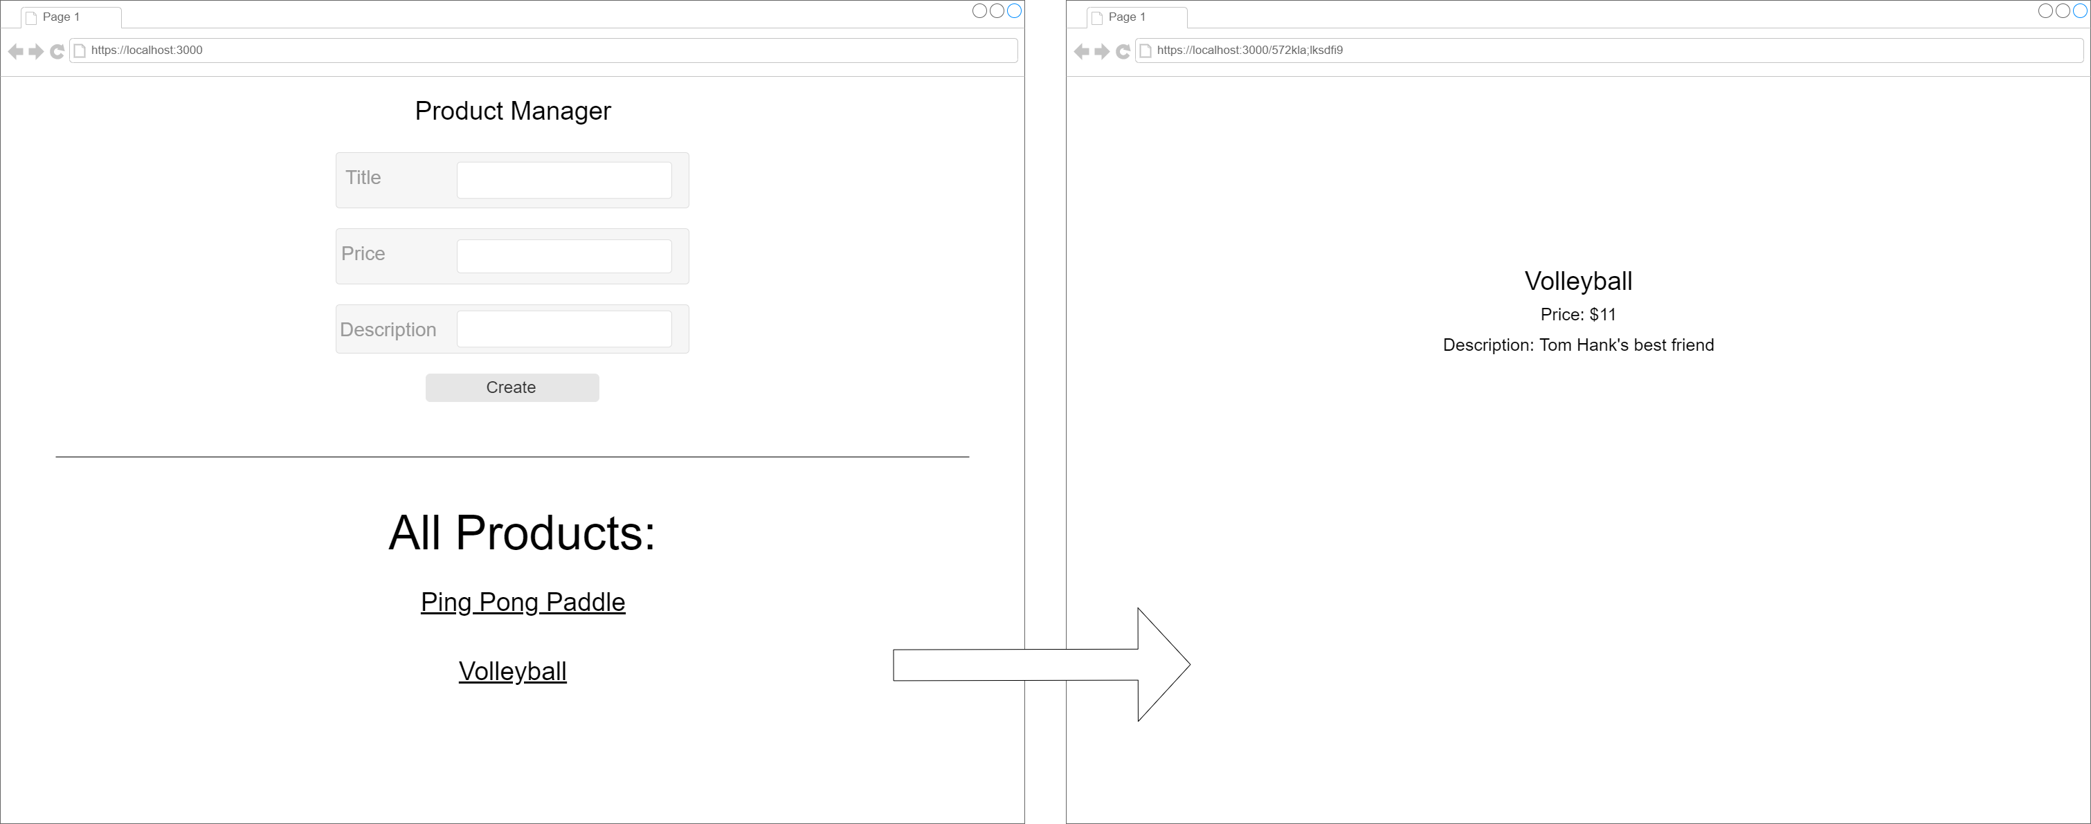

* Top of Form
* Create a component to list out all products on your main page
* Create a new view component that will let you see the details of a particular product (localhost:3000/:id)
* Link to the detail page in the list of products

Bottom of Form